**DOMAIN: Winter Winning Camp Day-2**

**NAME: Gurnoor Madaan UID: 22BCS15364**

**SECTION: 620/B DATE : 20-12-24**

**1. Majority Element**

**Problem Statement:** Given an array number of size n, return the majority element. The majority element is the one that appears more than n / 2 times.

**Code:**

#include <iostream>

#include <vector>

using namespace std;

int majorityElement(vector<int>& nums) {

int count = 0, candidate = 0;

for (int num : nums) {

if (count == 0) candidate = num;

count += (num == candidate) ? 1 : -1;

}

return candidate;

}

int main() {

vector<int> nums = {3, 2, 3};

cout << "Majority Element: " << majorityElement(nums) << endl;

return 0;

}

**Output:**

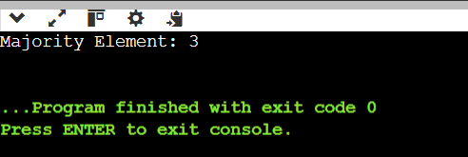

Majority Element: 3

**2. Single Number**

**Problem Statement:** Given an array nums where every element appears twice except for one, find that single one.

**Code:**

#include <iostream>

#include <vector>

using namespace std;

int singleNumber(vector<int>& nums) {

int result = 0;

for (int num : nums) {

result ^= num;

}

return result;

}

int main() {

vector<int> nums = {4, 1, 2, 1, 2};

cout << "Single Number: " << singleNumber(nums) << endl;

return 0;

}

**Output:**

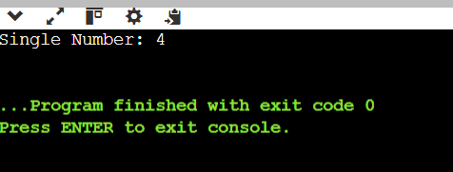

**3. Convert Sorted Array to BST**

**Problem Statement:** Convert a sorted array into a height-balanced Binary Search Tree (BST).

**Code:**

#include <iostream>

#include <vector>

using namespace std;

struct TreeNode {

int val;

TreeNode* left;

TreeNode* right;

TreeNode(int x) : val(x), left(nullptr), right(nullptr) {}

};

TreeNode* sortedArrayToBST(vector<int>& nums, int left, int right) {

if (left > right) return nullptr;

int mid = left + (right - left) / 2;

TreeNode* root = new TreeNode(nums[mid]);

root->left = sortedArrayToBST(nums, left, mid - 1);

root->right = sortedArrayToBST(nums, mid + 1, right);

return root;

}

TreeNode* sortedArrayToBST(vector<int>& nums) {

return sortedArrayToBST(nums, 0, nums.size() - 1);

}

void preOrder(TreeNode* node) {

if (!node) return;

cout << node->val << " ";

preOrder(node->left);

preOrder(node->right);

}

int main() {

vector<int> nums = {-10, -3, 0, 5, 9};

TreeNode* root = sortedArrayToBST(nums);

cout << "PreOrder Traversal: ";

preOrder(root);

cout << endl;

return 0;

}

**Output:**

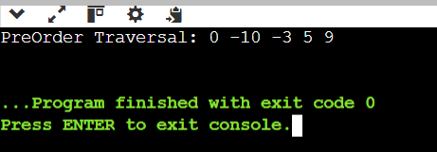

PreOrder Traversal: 0 -10 -3 5 9

**4. Merge Two Sorted Lists**

**Problem Statement:** Merge two sorted linked lists into one sorted list.

**Code:**

#include <iostream>

using namespace std;

struct ListNode {

int val;

ListNode* next;

ListNode(int x) : val(x), next(nullptr) {}

};

ListNode* mergeTwoLists(ListNode* l1, ListNode* l2) {

if (!l1) return l2;

if (!l2) return l1;

if (l1->val < l2->val) {

l1->next = mergeTwoLists(l1->next, l2);

return l1;

} else {

l2->next = mergeTwoLists(l1, l2->next);

return l2;

}

}

void printList(ListNode* head) {

while (head) {

cout << head->val << " ";

head = head->next;

}

cout << endl;

}

int main() {

ListNode* l1 = new ListNode(1);

l1->next = new ListNode(2);

l1->next->next = new ListNode(4);

ListNode* l2 = new ListNode(1);

l2->next = new ListNode(3);

l2->next->next = new ListNode(4);

ListNode* result = mergeTwoLists(l1, l2);

cout << "Merged List: ";

printList(result);

return 0;

}

**Output:**

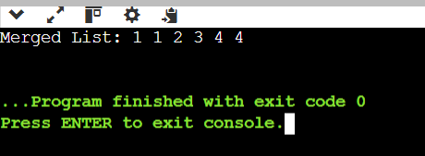

**5. Linked List Cycle**

**Problem Statement:** Determine if a linked list has a cycle.

**Code:**

#include <iostream>

using namespace std;

struct ListNode {

int val;

ListNode* next;

ListNode(int x) : val(x), next(nullptr) {}

};

bool hasCycle(ListNode* head) {

ListNode* slow = head;

ListNode* fast = head;

while (fast && fast->next) {

slow = fast->next;

fast = fast->next->next;

if (slow == fast) return true;

}

return false;

}

int main() {

ListNode* head = new ListNode(3);

head->next = new ListNode(2);

head->next->next = new ListNode(0);

head->next->next->next = new ListNode(-4);

head->next->next->next->next = head->next; // Creating a cycle

cout << "Linked List has cycle: " << (hasCycle(head) ? "True" : "False") << endl;

return 0;

}

**Output:**

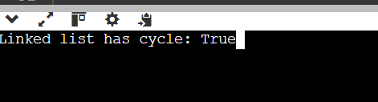

Linked List has cycle: True

**6. Pascal's Triangle**

**Problem Statement:** Given an integer numRows, return the first numRows of Pascal's triangle.

**Code:**

#include <iostream>

#include <vector>

using namespace std;

vector<vector<int>> generate(int numRows) {

vector<vector<int>> triangle;

for (int i = 0; i < numRows; i++) {

vector<int> row(i + 1, 1); // Create a row with 'i+1' elements initialized to 1

for (int j = 1; j < i; j++) {

row[j] = triangle[i-1][j-1] + triangle[i-1][j];

}

triangle.push_back(row);

}

return triangle;

}

int main() {

int numRows = 5;

vector<vector<int>> result = generate(numRows);

for (auto row : result) {

for (int num : row) {

cout << num << " ";

}

cout << endl;

}

return 0;

}

**OUTPUT:**

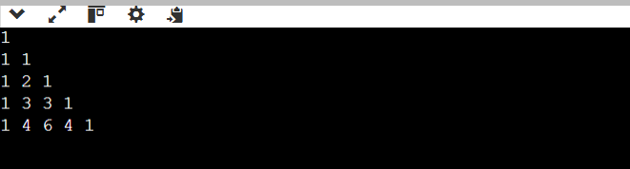

**7.** **Container With Most Water**

**Problem Statement:** You are given an integer array height of length n, where each element represents the height of a vertical line drawn at that position. Find two lines that, together with the x-axis, form the container that can store the most water. Return the maximum amount of water the container can hold.

**Code:**

#include <iostream>

#include <vector>

#include <algorithm>

using namespace std;

int maxArea(vector<int>& height) {

int left = 0, right = height.size() - 1;

int max_area = 0;

while (left < right) {

int area = min(height[left], height[right]) * (right - left);

max_area = max(max_area, area);

if (height[left] < height[right]) {

left++;

} else {

right--;

}

}

return max_area;

}

int main() {

vector<int> height = {1, 8, 6, 2, 5, 4, 8, 3, 7};

cout << "Max Area: " << maxArea(height) << endl;

height = {1, 1};

cout << "Max Area: " << maxArea(height) << endl;

return 0;

}

**Output:**

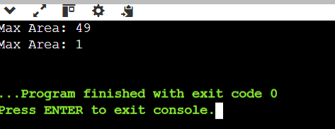

**8.** **Jump Game II**

**Problem Statement:** You are given a 0-indexed array nums where each element represents the maximum jump length from that position. Starting at nums[0], you need to return the minimum number of jumps to reach the last index nums[n-1]. It's guaranteed that you can reach the last index.

**Code:**

#include <vector>

#include <iostream>

#include <algorithm>

using namespace std;

int jump(vector<int>& nums) {

int n = nums.size();

int jumps = 0;

int farthest = 0;

int end = 0;

for (int i = 0; i < n - 1; i++) {

farthest = max(farthest, i + nums[i]);

if (i == end) {

jumps++;

end = farthest;

if (end >= n - 1) break;

}

}

return jumps;

}

int main() {

vector<int> nums1 = {2, 3, 1, 1, 4};

vector<int> nums2 = {2, 3, 0, 1, 4};

cout << "Minimum jumps for nums1: " << jump(nums1) << endl;

cout << "Minimum jumps for nums2: " << jump(nums2) << endl;

return 0;

}

**Output:**

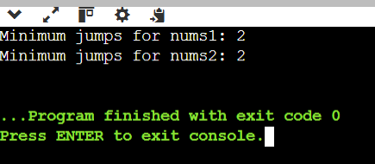

**9.** **Maximum Number of Groups Getting Fresh Donuts**

**Problem Statement:** You are given a list of groups, and a batch Size A group is considered happy if they all get fresh donuts, meaning that their order should not be mixed with leftovers from other groups.

**Code:**

#include <vector>

#include <algorithm>

#include <iostream>

using namespace std;

int maxHappyGroups(int batchSize, vector<int>& groups) {

int happyCount = 0;

int currentDonuts = 0;

sort(groups.begin(), groups.end(), greater<int>());

for (int groupSize : groups) {

if (groupSize <= currentDonuts) {

currentDonuts -= groupSize;

happyCount++;

} else {

currentDonuts = batchSize - groupSize;

}

}

return happyCount;

}

int main() {

vector<int> groups1 = {1, 2, 3, 4, 5, 6};

vector<int> groups2 = {1, 3, 2, 5, 2, 2, 1, 6};

cout << "Maximum happy groups for test case 1: " << maxHappyGroups(3, groups1) << endl;

cout << "Maximum happy groups for test case 2: " << maxHappyGroups(4, groups2) << endl;

return 0;

}

**OUTPUT:**

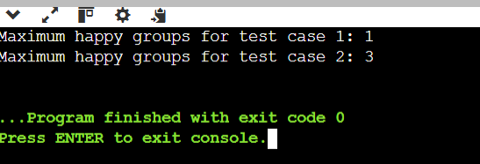

**10. Find Minimum Time to Finish All Jobs**

**Problem Statement:** To solve the problem of minimizing the maximum working time of any worker when assigning jobs, we can approach it using backtracking combined with binary search. This combination will help us find an optimal solution efficiently within the problem constraints.

**Code:**

#include <vector>

#include <iostream>

#include <algorithm>

using namespace std;

bool canAssignJobs(const vector<int>& jobs, int k, int maxTime) {

vector<int> workers(k, 0); // worker workload

return backtrack(jobs, 0, workers, maxTime);

}

bool backtrack(const vector<int>& jobs, int index, vector<int>& workers, int maxTime) {

if (index == jobs.size()) return true;

int job = jobs[index];

for (int i = 0; i < workers.size(); i++) {

if (workers[i] + job > maxTime) continue;

workers[i] += job;

if (backtrack(jobs, index + 1, workers, maxTime)) return true;

workers[i] -= job;

if (workers[i] == 0) break;

}

return false;

}

int minTimeToFinishJobs(vector<int>& jobs, int k) {

int left = *max_element(jobs.begin(), jobs.end());

int right = accumulate(jobs.begin(), jobs.end(), 0);

sort(jobs.begin(), jobs.end(), greater<int>());

while (left < right) {

int mid = left + (right - left) / 2;

if (canAssignJobs(jobs, k, mid)) {

right = mid;

} else {

left = mid + 1;

}

}

return left;

}

int main() {

vector<int> jobs1 = {3, 2, 3};

int k1 = 3;

vector<int> jobs2 = {1, 2, 4, 7, 8};

int k2 = 2;

cout << "Minimum max working time for jobs1: " << minTimeToFinishJobs(jobs1, k1) << endl;

cout << "Minimum max working time for jobs2: " << minTimeToFinishJobs(jobs2, k2) << endl;

return 0;

}

**OUTPUT:**

